- UK Chancellor Rachel Reeves confirmed that she would make material changes to the fiscal rules in order to boost public investment. A move to targeting a fall in public sector net financial liabilities over the course of the parliament looks likely. But we expect Reeves to keep a decent amount of room against her new debt rule to mitigate market concerns about higher borrowing.
- Comments from several Monetary Policy Committee members highlighted that the committee remains deeply divided over the outlook for interest rates. Recent data has likely tilted the majority towards a slightly more dovish view, but we suspect they will want to wait to see the Budget before signalling a faster pace of cuts.
In what has been a quieter week for economic releases, attention has instead been focused on comments made by key public officials which have shed light on the UK's two important upcoming economic policy decisions – the Autumn Budget on October 30 and the Monetary Policy Committee's November meeting.
Writing in the Financial Times on Thursday, Chancellor Rachel Reeves provided further clarity on the changes she will make to the UK's fiscal rules ahead of next week's Budget. Reeves confirmed that she would seek to boost investment by altering the measure of debt used in the government's borrowing rule, which currently states that the ratio of public sector net debt (excluding the Bank of England) to GDP should fall five years ahead. Though the Chancellor did not disclose which measure of debt would be used instead, it has been widely reported that the government will commit to getting public sector net financial liabilities (PSNFL) falling as a share of the economy during the course of this parliament.
As we've previously discussed, a shift to targeting PSNFL could open up about £50bn of additional space to invest compared to the existing debt rule (Chart 1). Our interpretation of Reeves' comments is that she is likely to use this extra fiscal space cautiously. Indeed, we think there's a decent chance that the government will only use about half of the extra headroom to avoid the sharp fall in public sector net investment that had been projected at the March Budget, in an effort to mitigate market concerns about higher borrowing.
Chart 1: Changing the debt rule will open a lot more room for the Chancellor to invest
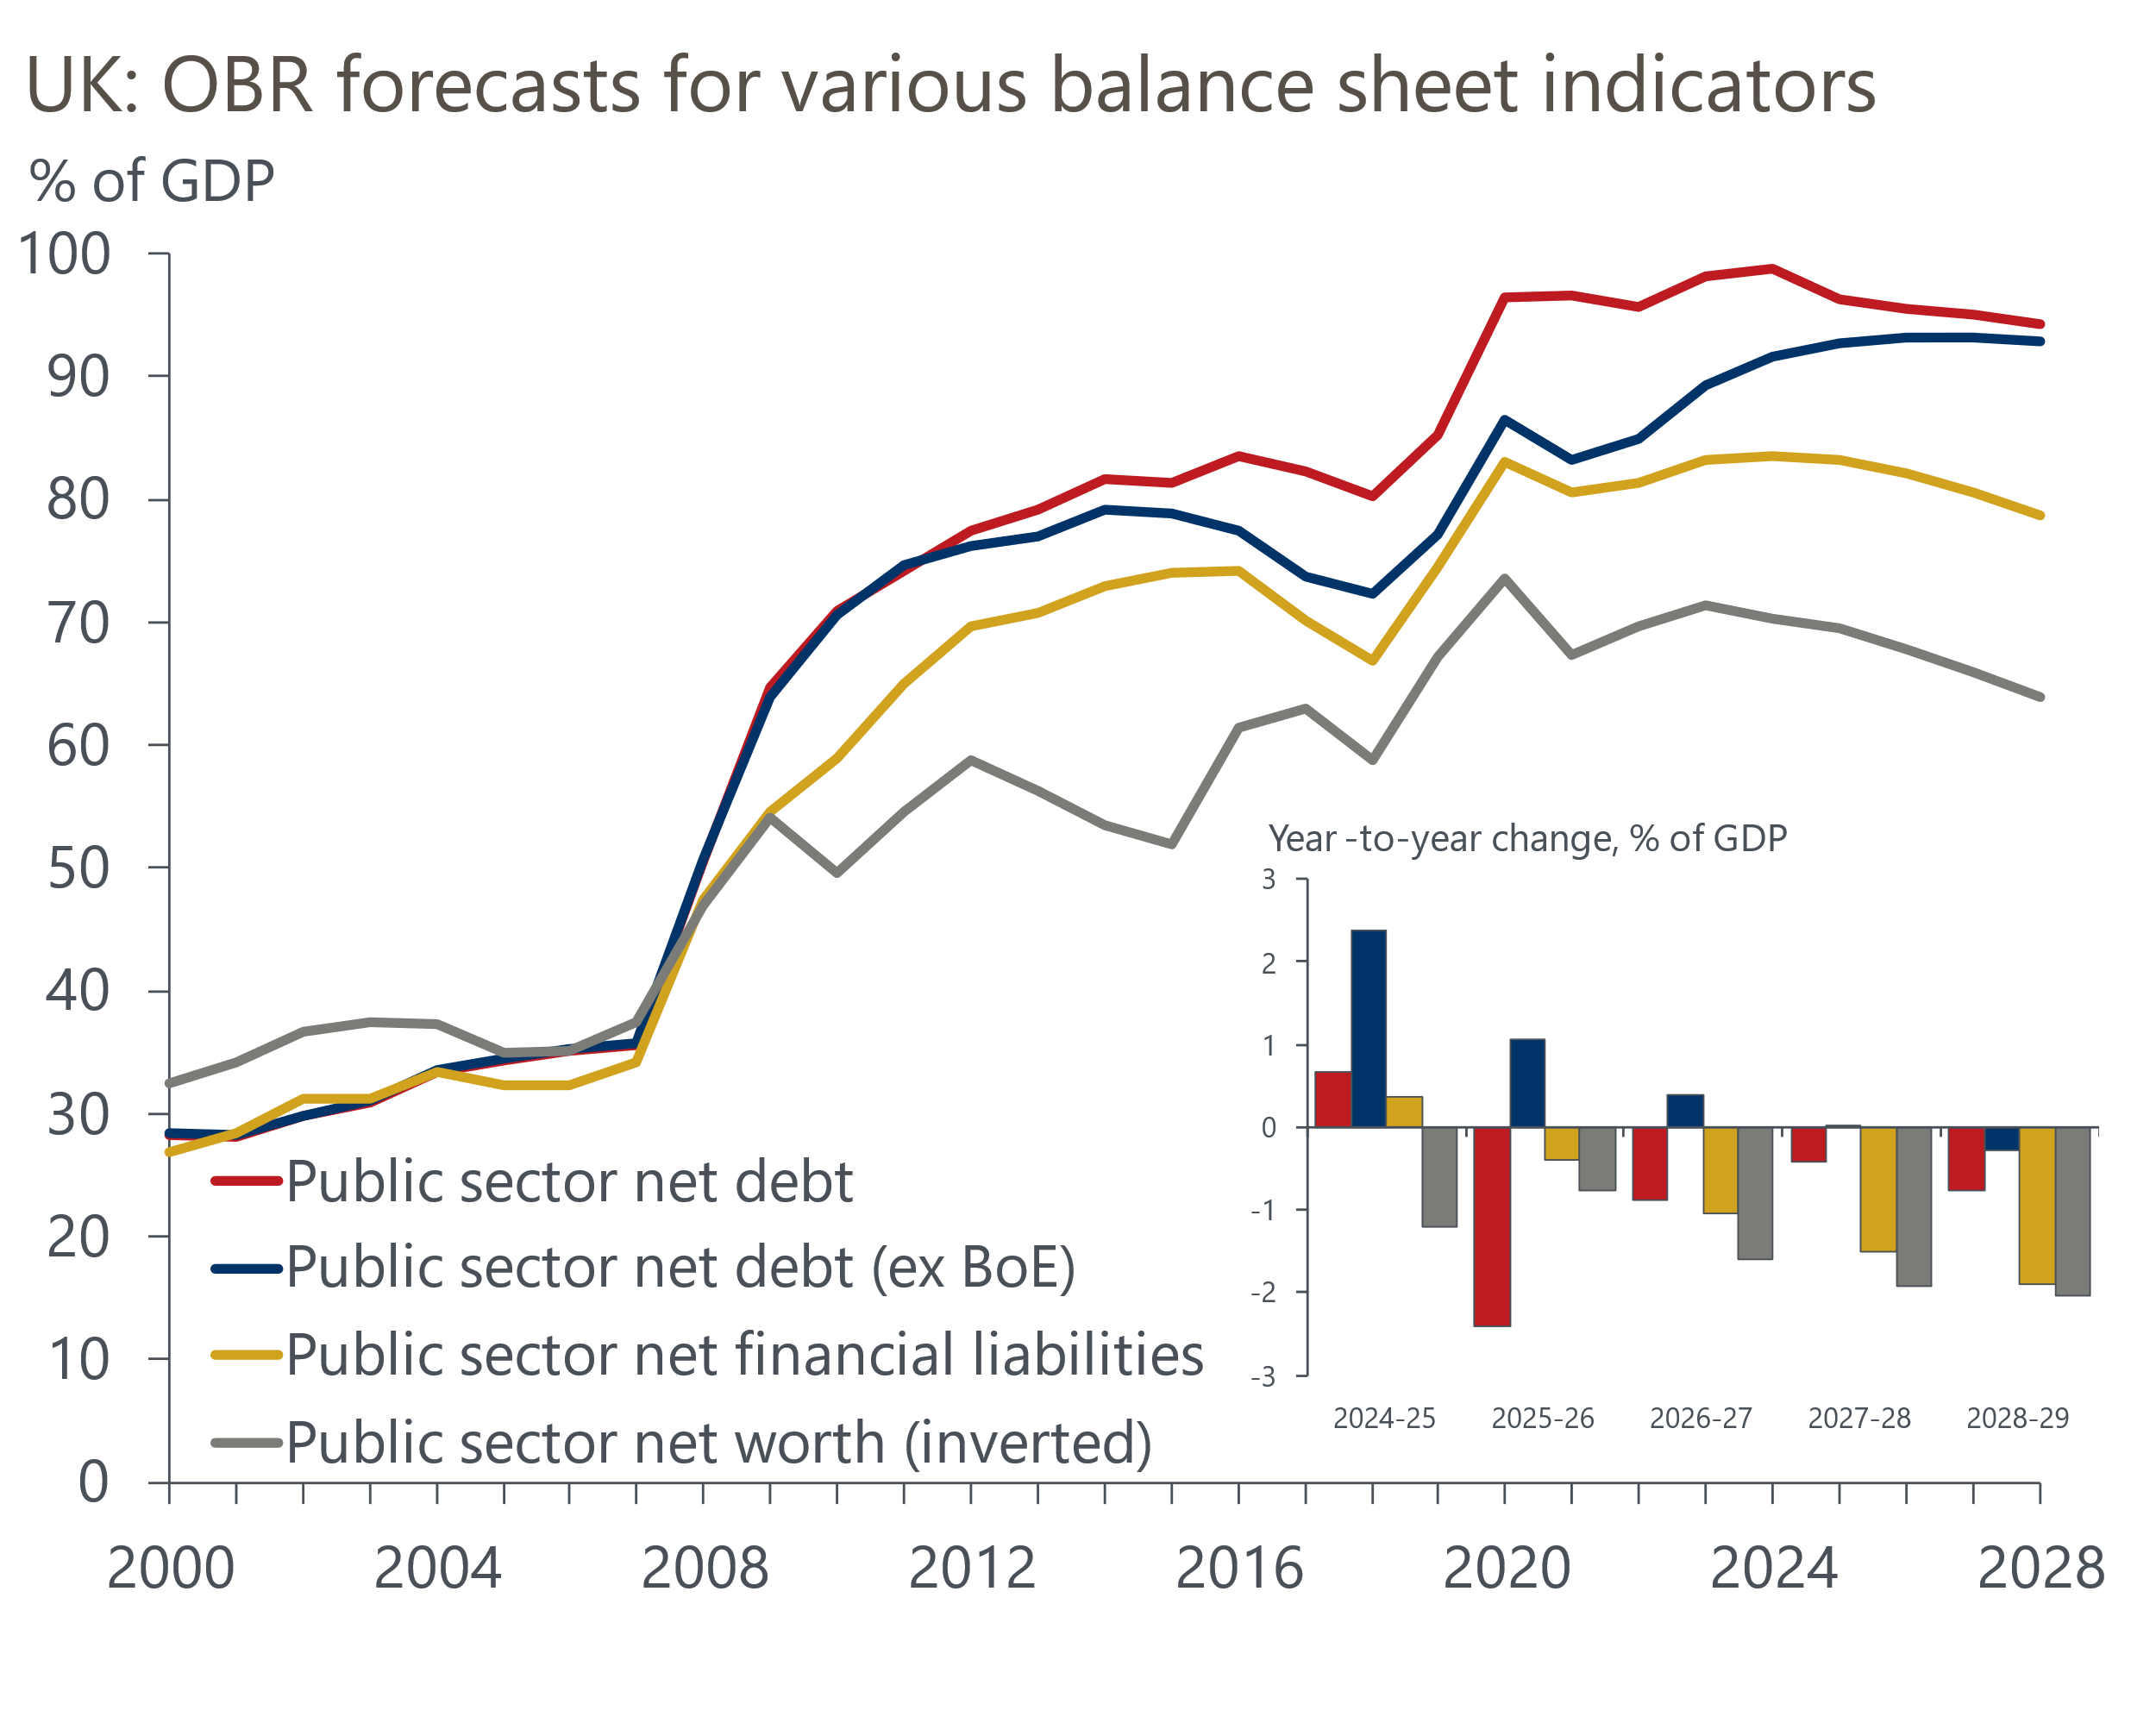
Source: OBR

Though higher borrowing will be used to boost capital expenditure, the Chancellor will still have to implement a series to tax rises to offset greater day-to-day spending pressures. On balance, this week's fiscal developments suggest that the scale of tightening over the course of this parliament may be slightly less than some had previously feared. But the need for additional current spending to be full funded by tax rises means the consolidation is likely to be front-loaded.
Switching gears to monetary policy, while we regard another 25bps rate cut at the MPC's November meeting as virtually certain, there remains a degree of uncertainty regarding the pace of the rate-cutting cycle further out. With several MPC members speaking at the IMF's annual meeting this week, our focus was on whether there would be any indication that a majority of MPC members are willing to depart from the 'cut-hold' pattern and back a faster pace of rate cuts through the winter.
In the event, Bank of England Governor Andrew Bailey struck a somewhat dovish tone when speaking at the Institute of International Finance, stating he was seeing a "good story" when it came to slowing headline inflation and that this had "actually taken place faster than we expected it to". We see Bailey's comments as probably more closely aligned with the first inflation scenario outlined in the minutes of recent MPC meetings – namely that price- and wage-setting dynamics will respond to an unwinding of global shocks and inflation persistence should dissipate without a significant rise in unemployment. We suspect recent data has probably tilted the committee's majority more towards this benign scenario, meaning a faster pace of rate cuts through the winter now looks like a slightly more material possibility than it had previously.
However, the MPC remains deeply divided. At the other end of the spectrum, external member Catherine Mann reiterated her views this week that structural shifts had altered the relationship between wage and price formation, and suggested that rate cuts may have been premature. While it's unlikely that Mann will vote for looser policy soon, her views represent a minority on the committee and are unlikely to shape the MPC's upcoming decisions.
The only economic data release of note this week provided mixed messages on the near-term outlook for monetary policy. October's flash S&P Global survey reported a drop in the composite PMI to 51.7 from 52.6 in September, an 11-month low, with both sectors reporting weaker activity growth (Chart 2). That survey respondents cited the upcoming Budget as a source of near-term uncertainty, just as they did in the latest GfK consumer confidence survey, suggests some of the recent slowdown may prove temporary. But signs of softer growth are still in keeping with our view that growth is likely to come in a bit weaker in H2 2024.
Chart 2: October's weaker flash composite PMI is consistent with a softer pace of growth in H2 2024
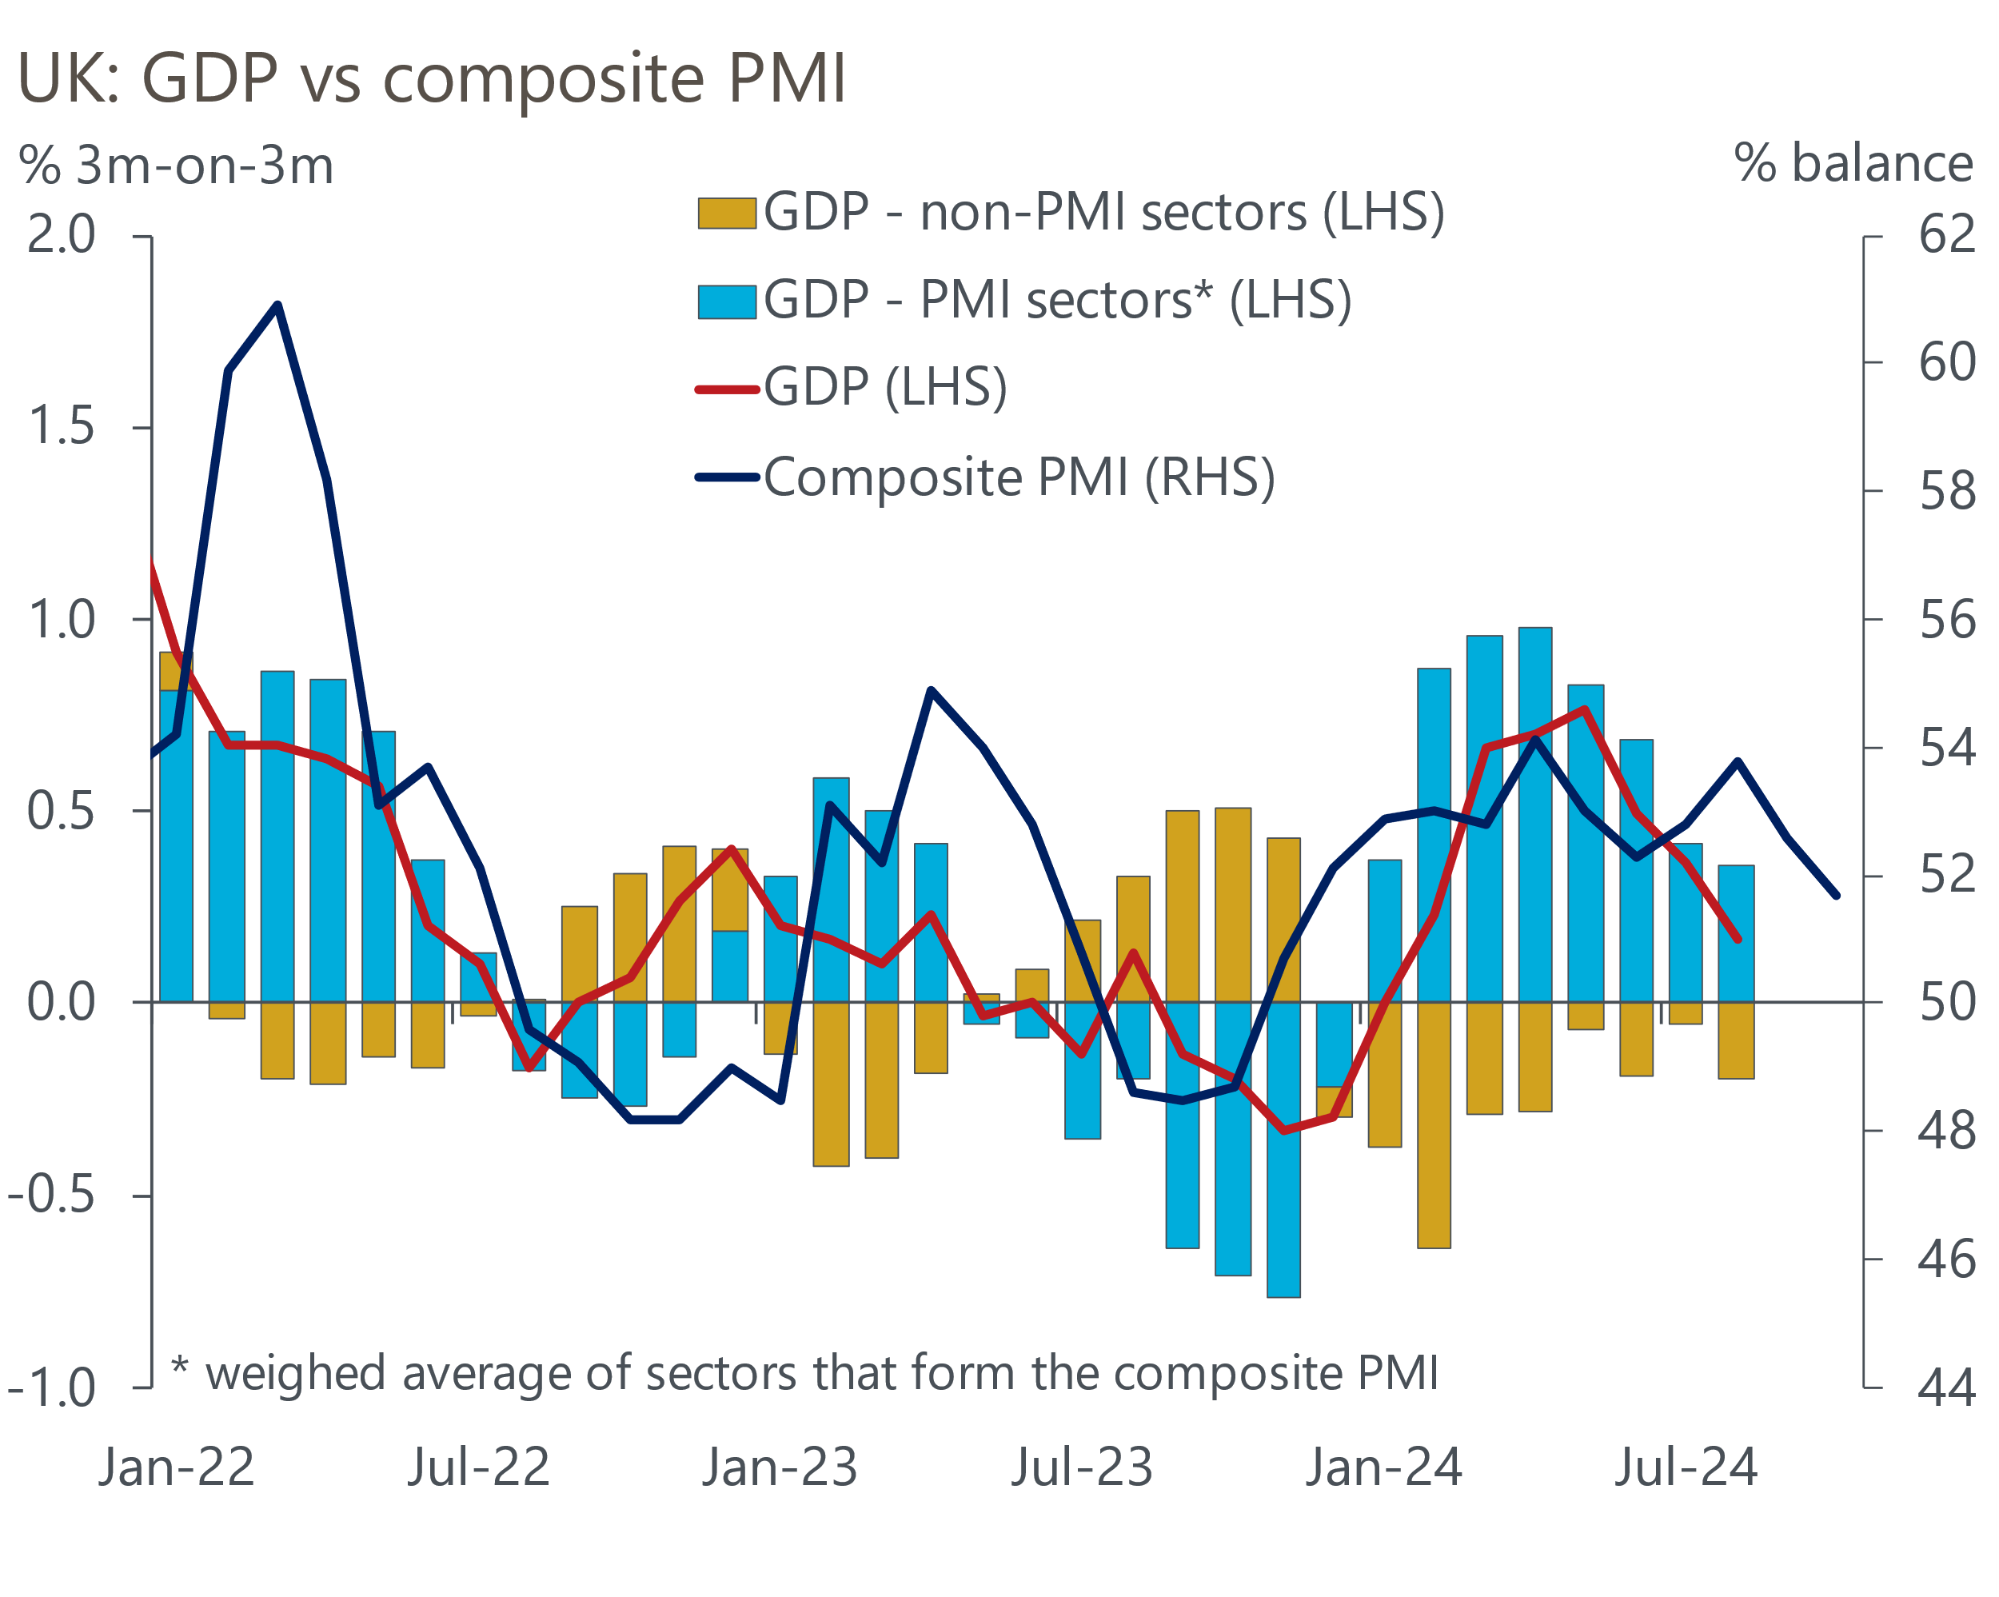
Sources: Oxford Economics, ONS, S&P Global
However, reports of softer economic momentum were accompanied by an uptick in the S&P Global survey's output price balance. We suspect signs of lingering inflationary pressure will mean that the MPC will want to wait for news from the Budget and the BoE's upcoming forecast round before firming their views on the possibility of a more aggressive rate-cutting cycle.

The week ahead
The Autumn Statement is the highlight of next week's economic calendar. Shortly after taking office, the Chancellor presented Treasury analysis that found that departmental spending was likely to overshoot the plans presented in March's Budget by £22bn (0.8% of GDP) in the current fiscal year. Around half of the overspend resulted from Reeves accepting the recommendations of the public sector pay boards to award much higher pay increases than had been budgeted for, reflecting the impact of high inflation. Much of this year's overspend will reoccur in future years, so with the Treasury analysis only covering the current year, it didn't address implausibly tight spending plans for subsequent years or other medium-term cost pressures.
Absent favourable forecast revisions from the Office for Budget Responsibility, the government will need to offset higher current spending with tax rises. Our forecast assumes the government raises taxes by £10bn (0.4% of GDP), on top of the measures in Labour's pre-election manifesto.
The Chancellor has announced that she will change the debt rule to create more space for investment. It has been widely reported that Reeves will commit to getting public sector net financial liabilities falling as a share of the economy during the course of this parliament. Such a move could create an extra £50bn of headroom compared with the current rule. If the Chancellor were to target this measure of debt, we would expect her to keep a considerable amount of headroom against the new fiscal rules to mitigate any financial market concerns about additional borrowing.
September's Money & Credit release is likely to show a further improvement in mortgage demand. There's been a very strong relationship between quoted mortgage rates and mortgage approvals over the past couple of years. So, with quoted mortgage rates having fallen back considerably in recent months, another strong approvals reading looks to be in the offing. We forecast that mortgage approvals rose to 65,900 in September, from 64,700 in August. However, we anticipate a fall in net secured lending to £1.6bn. Repayments were very low in July and August, and we expect an unwinding of this weakness to more than offset a modest uptick in gross mortgage lending.
On the unsecured side, gross lending and repayments rose strongly in August's data. There's a good chance that both experienced some payback in September, but the month's soft retail sales outturn suggests a fallback in gross lending may be the slightly stronger force. As a result, we forecast that net unsecured lending eased to £1.2bn from £1.3bn in August.
Elsewhere, October's flash S&P Global manufacturing PMI eased to 50.3, from 51.5. Survey respondents reported that a slower pace of activity growth in the sector was driven by an outright decline in new orders amid signs of some Budget-related uncertainty. With no clear pattern to revisions, we expect the final results to come in close to this week's flash survey.
Table 1: Week ahead calendar
Date | Events | Period | Measure | Unit | Previous | Forecast
Oct 29 | Mortgage approvals | Sep | Level | 000s | 64.7 | 65.9
Oct 29 | Mortgage lending | Sep | Net lending | £bn | 2.9 | 1.6
Oct 29 | Consumer credit | Sep | Net lending | £bn | 1.3 | 1.2
Oct 30 | Autumn Statement
Nov 1 | Halifax house prices | Oct | m/m | % | 0.3 | 0.3
Nov 1 | Halifax house prices | Oct | y/y | % | 4.7 | 4.3
Nov 1 | S&P Global manufacturing | Oct | PMI | % bal | 50.3 | 50.3
Source: Oxford Economics

Key forecasts
Table 2: UK forecast overview
(Annual percentage changes unless specified)
 | 2022 | 2023 | 2024 | 2025 | 2026 | 2027
GDP | 4.8 | 0.3 | 1.0 | 1.5 | 1.6 | 1.7
Private consumption | 7.3 | 0.5 | 0.8 | 1.9 | 1.8 | 1.6
Fixed investment | 5.1 | -0.1 | 0.6 | 1.3 | 2.5 | 2.1
Government consumption | 0.6 | 0.6 | 2.3 | 1.9 | 1.5 | 1.5
Exports of goods and services | 12.6 | -2.2 | -0.8 | 3.0 | 1.9 | 1.6
Imports of goods and services | 13.0 | -3.4 | 2.8 | 3.1 | 2.5 | 1.7
Industrial Production | -6.4 | -1.2 | -0.8 | 1.0 | 1.2 | 0.9
Consumer prices | 9.1 | 7.3 | 2.5 | 2.5 | 2.3 | 2.1
Unemployment rate (%) | 3.9 | 4.0 | 4.3 | 4.3 | 4.1 | 3.9
Current a/c balance (% of GDP) | -2.2 | -2.0 | -2.9 | -2.8 | -2.9 | -2.8
Government balance (% of GDP) | 4.1 | 4.9 | 3.7 | 2.8 | 2.1 | 1.4
Cen. bank policy rate (%, EOP) | 3.50 | 5.25 | 4.75 | 3.75 | 2.75 | 2.00
10yr govt. bond yield (%, EOP) | 3.67 | 3.54 | 4.00 | 3.75 | 3.24 | 2.85
Exchange rate (US$ per £, EOP) | 1.20 | 1.27 | 1.31 | 1.32 | 1.32 | 1.33
Exchange rate (euro per £, EOP) | 1.13 | 1.15 | 1.19 | 1.18 | 1.18 | 1.17
Source: Oxford Economics
Table 3: Quarterly forecasts for the UK
 | 2024 |  |  |  | 2025
 | Q1 | Q2 | Q3 | Q4 | Q1 | Q2 | Q3 | Q4
GDP (% year) | 0.3 | 0.7 | 1.1 | 1.9 | 1.6 | 1.5 | 1.6 | 1.5
CPI inflation (% year) | 3.5 | 2.1 | 2.1 | 2.4 | 2.5 | 2.3 | 2.6 | 2.5
Bank Rate (%, EOP) | 5.25 | 5.25 | 5.00 | 4.75 | 4.50 | 4.25 | 4.00 | 3.75
10yr gilt yield (%, EOP) | 3.95 | 4.17 | 4.00 | 4.00 | 3.98 | 3.92 | 3.84 | 3.75
US$ per £ (EOP) | 1.26 | 1.26 | 1.34 | 1.31 | 1.31 | 1.32 | 1.32 | 1.32
Euro per £ (EOP) | 1.17 | 1.18 | 1.20 | 1.19 | 1.19 | 1.19 | 1.19 | 1.18
Source: Oxford Economics

Latest Country Economic Forecast:
October 15, 2024

Recent publications

Data Insights
October PMI gives further signal growth has softened in H2
September public finances point to another borrowing overshoot
September's data confirm a strong Q3 for retail sales
CPI inflation temporarily dipped in September
Cooling pay growth keeps BoE on track to cut in November

Research Briefings
Can PSNW be used for a fiscal rule?
Why business investment is poised to pick up
Looser labour market could pave the way for faster rate cuts
How changing the debt rule could shape the Budget
MPC takes a breath, but cuts likely to resume in November

Contacts

Oxford Economics' UK team
- Andrew Goodwin - Chief UK Economist - agoodwin@oxfordeconomics.com
- Edward Allenby - UK Economist - eallenby@oxfordeconomics.com

